Mary Carrico Catholic School
Extended Care
Parent Handbook
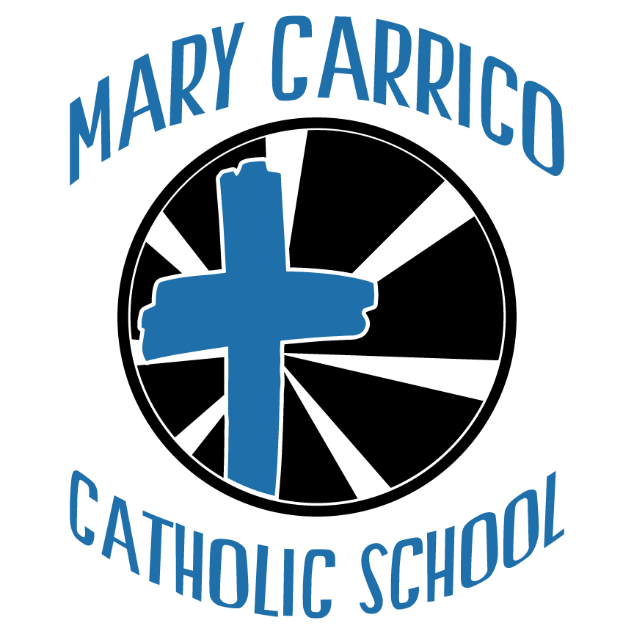

Extended Care

MCCS Extended Care Parent Handbook

Parents/Guardians,

Welcome to MCCS. We are glad you chose to enroll your child in our program.

We hope you will feel that you have made a good choice for your child. We will work hard to maintain your trust. The staff is ready to assist you with any questions or concerns you may have about the program.

Again, welcome!

Philosophy

MCCS Extended Care will strive to provide an atmosphere where children can develop a positive self-concept and a healthy respect for people different from themselves. Children are accepted into the program regardless of race, gender, religion, or ethnic origin. Children with special needs are welcome in the program if their needs can be met while maintaining an appropriate program for all children.

We believe all areas of a child’s development are important, so our program is designed to stimulate and nurture growth and development in all areas: physical, social, emotional, spiritual and cognitive.

We believe growth and development occur when children have opportunities to explore their world through play. Because we endorse these principles, our program allows for learning through:

Faith: learning about God’s creation and His great love for us.

Creative expression: using crayons, paint, glue, scissors, and playdough for creative expression and experimentation.

Music: songs, dances, rhythm games, and instruments.

Language: communication with adults and children, sharing books, drama, and learning to listen in pleasant and satisfying activities.

Self-directed activities: building with blocks, using small manipulative toys, and playing in imaginary situations foster a sense of self-confidence and esteem.

Teacher-directed activities: opportunities for small group discussion and experiences with science, math, and other topics of interest.

Outdoor play: group games, running, getting a breath of fresh air.

We believe that the teaching methods and techniques used must be based on a proper understanding of child development and that there should be an emphasis on the importance of fostering good relationships so as to promote healthy attitudes. Also since play is the language and primary learning mode for children, we expect to plan for it and recognize its value for the young child.

Television is not a part of the daily schedule. However, we may occasionally watch a television program which is both age appropriate and educational.

Open Door Policy

Parents are welcome in the center at any time during the hours of operation to observe their child’s activities and/or to participate in the center activities. However, Visitation Policy may be revised in the case of Covid or other state regulations.

Volunteers

Parents or other volunteers are a special treat for children and teachers. You are invited to help out whenever your schedule permits.

Parent Communication

Please check class dojo and the parent bulletin board located in the pre-school room for information on policies, upcoming events, menus, parenting articles, etc.

Special Feature

MCCS is a smoke-free facility. Smoking is not allowed on the premises by

parents or staff.

Services offered

Hours of operation: 7:00 – 5:30 Monday – Friday

Class Days Preschool Tuition Extended Care Fees

3 days - Tu, W, Th $100 per week (11-5:30) $45 per week

5 days - M,T,W,Th,F $115 per week (11-5:30) $55 per week

• For your preschooler, you will choose either a 3 day program, a 5 day program, or a 3 or 5 day program with extended care. You will have 10 equal payments, the last one being due on May 1, 2027. You are always welcome to pay ahead, and when you have paid off the total amount you will be finished.

• For the entire year of preschool you will pay the following (Based on a 35 week school year, and depending on which schedule you sign up for.)

⇒ 3 Day Preschool — $3500

⇒ 3 Day + Extended Care — $5075

⇒ 5 Day Preschool — $4025

⇒ 5 Day + Extended Care — $5950

• A non-refundable $100 per child registration fee for preschool is payable when registration paperwork is turned in.

• If you have 2 children in preschool at the same time, you will receive a 25% discount on the second child.
- Any parent whose child stays past 5:30 PM is subject to a late fee of $5 for every 15 minutes per child.

Mary Carrico Extended Care qualifies for the child care assistance program (CCAP). The Child Care Assistance Program (CCAP) provides support to help families pay for child care. The Division of Child Care is responsible for all child care provider support and The Division of Family Support helps clients apply for the program.

Eligibility for the Child Care Assistance Program
Applicants must meet eligibility requirements in 922 KAR 2:160. An applicant can see if they are eligible by using the Prescreening Tool. To apply please call toll-free (855) 306-8959 or visit kynect.

Weather-Related Closing

MCCS Extended Care will follow the Daviess County Public Schools yearly calendar. If Daviess County schools are closed, MCCS Extended Care will be closed.

Daily Operations

Admission

Before a child is admitted to MCCS Extended Care, parents must return a completed application.

Before attending the program, children must have and maintain a copy of an up-to-date- immunization certificate.

All preschool age children should have at least one change of clothes at the center in case of an accident. Please label the clothes with your child’s name in permanent marker.

Each preschool age child staying in extended care needs a sheet/blankets/re-usable grocery bag to store belongings. Sheets and blankets need to be taken home each Friday to be laundered and returned the following Monday.

Withdrawal

Parents are requested to give a minimum two (2) week notice for withdrawal from the Center. A child who is absent for 5 consecutive days without parent contact will be assumed to be withdrawn from the Center.

Drop Off and Pick up Procedures

All children must be signed in by the adult bringing the child to the center. As you sign-in, note time of arrival. When you pick up your child you must sign out on the same sheet, notice time of departure.

Drop off is at the cafeteria from 7:00-7:30am and pick up will be at the gym door.

If your child will be eating breakfast at school, they should arrive by 7:15am.

If your child will be a car rider at the end of the school day (2:40pm), please let the teacher know and your child will be escorted to the car line with the K-8 students.

If your child will stay later than 2:45 pm, you must ring the front doorbell and your child will be brought to the front door.

If a person other than the parent is picking up the child, picture identification is required. If a person who is not on the pre-approved pick up list will be picking up the child, the director MUST be notified in advance of the person’s full name. The child will not be released if notification is not made.

**Parents may have access to their child at any time unless we have LEGAL DOCUMENTATION on file stating otherwise.

Safety Policies

We make every effort to provide a safe and secure environment for children. If an accident should occur a written report will be made with one copy going to the parent and one copy remaining in the child’s file. For any accident requiring medical attention beyond first aid, parents, will be notified as soon as possible.

Emergency Procedure

We take every precaution to prevent injury to your child. But in the event of an accident or medical emergency we will proceed as follows.

A certified staff member administers first aid or CPR, depending of the severity of the injury. We will notify you by telephone immediately.

If the situation warrants, a second staff member calls 911 and requests emergency transport to Owensboro Regional Medical System.

If you are not available, we will notify the person you designated as your emergency contact.

If a parent or the emergency contact does not arrive before the emergency transport does, the person in charge of the program at the time accompanies the child to the hospital.

Health Policies

We want to protect the health of all the children and staff. In order to do this, we ask that you follow the guidelines below:

Please keep your child home if:

S/he has a temperature of 100.4 degrees. Child must be fever and symptom free without fever-reducing medication for 24 hours before returning to care.

S/he has had two or more episodes of diarrhea in the past 48 hours

S/he has vomited more than once in the last 48 hours. Child cannot return until after 48 hours of last episode.

S/he has mouth sores with drooling, unless a doctor determines the child’s illness is not communicable.

S/he has a rash with a fever of behavioral change until a health professional determines the child may be in care.

S/he has pink eye with white or yellow discharge until 24 hours after treatment has started.

S/he has scabies, head lice, or other infestations until 24 hours after treatment is started and child is declared nit-free.

S/he has any of the contagious diseases until a health professional determines the child may be in care.

tuberculosis

impetigo

chicken pox

pertussis (whooping cough)

strep throat or other strep infection

measles

mumps

hepatitis

rubella

shingles

S/he has any other disease or condition that may be transmitted to others, or keeps the child from participating in routine activities in the program.

Prescription medication in the original bottle with the child’s name and doctor’s name can be administered. Parents MUST complete and sign a Medicine Sheet daily before any medication can be given.

Illness

If your child becomes sick at school, we will isolate him or her as much as possible and contact you immediately. After you have been contacted; please make arrangements for your child to be picked up within one hour. If you are unavailable, we will contact the emergency contact person(s) to pick up your child.

Allergies and Special Diets

If your child has allergies to food or other substances, it is of utmost importance that you let the center staff know about them. These will be posted in the child’s classroom so any staff person with your child will know about the allergy.

You must have a doctor’s statement describing any and all the child’s allergies, probable reactions and first aid treatment necessary. If the allergy is potentially life threatening, the parent must provide the first-aid kit and training necessary to counteract the allergic reaction.

Meals and Snacks

Meals and snacks served by MCCS are nutritious and meet the guidelines set by the federal child care food program. Food is served on the following schedule:

7:00 AM Breakfast

9:00 AM Snack

11:00 AM Lunch

2:40 PM Snack for those staying in after school

Meals are served in a pleasant and relaxed atmosphere. Preschool teachers eat with the children to model appropriate table behavior and manners. Children are encouraged (but not forced) to try new foods. Food is never used as a punishment or a reward.

Weekly menus are posted on the parent board.

Naptime (for preschool children staying all day)

After lunch a quiet rest period is scheduled. The center provides a cot for each child. Parents should provide a sheet and blanket labeled with the child’s name for naptime. These items will be sent home weekly to be laundered. Children shall be given the opportunity to rest for an adequate amount of time and then allowed to play quietly for the remainder for the naptime if they choose not to sleep.

Outdoor Play

We view the playground as an extension of the classroom. We allow children to be outside each day as weather permits. Because our playground is not fenced in, you will be asked to sign a permission form each year to allow your child access to the playground. When there is a weather advisory, the children will have access to the gym.

Things to Leave at Home

Please leave the following items at home or in the car:

Snacks and food

Markers, scissors, art supplies

Breakable items

Candy

Money

Toys

Holiday Celebrations/Birthdays

Holiday parties will be scheduled for Halloween, Christmas, and Valentine’s Day. Near the time of the celebrations, special information will be sent home requesting parent assistance with the parties. If you volunteer to bring food or drink, please remember that licensing requires that all food products be store bought.

Each child’s birthday is recognized. If you would like your child to celebrate at the center, please discuss bringing refreshments with the director. Gifts will not be exchanged.

Code of Conduct

Corporal punishment (spanking, slapping, hitting,) is prohibited. This applies to parents and staff while on center property. We also will not allow any type of verbal or emotional abuse of any persons. By law we are obligated to report incidence of such abuse directed at children to the Department of Protection and Permanency.

Parents are expected to adhere to these rules as well. Offensive language is strongly discouraged because young children are listening and imitating all the time.

We believe that a child’s self-esteem should be protected at all times. We will use positive guidance techniques to help children learn self-discipline such as redirection, encouragement, evaluation, and rearrangement of the classroom environment, and getting down on children’s level when talking to them. These strategies address behavior BEFORE problems arise.

If a problem should arise and persist, we may use time out and discuss possible solutions to the behavior problems with the parents. Time out is used as a last resort to stop destructive or aggressive behavior.

Very occasionally, a child may be so out of control that gentle physical restraint may be necessary to help the child regain self-control.

Staffing

The director and staff meet all the requirements for child care center staff. Staff members are encouraged to participate in on-going training and professional development opportunities.

Kentucky minimum staffing requirements will be followed at all times

3 years 1 staff per: 12 children

3-4 years 1 “ “ 12 children

4-5 years 1 “ “ 14 children

5-7 years 1 “ “ 15 children

7 & up 1 “ “ 20 children

When groups include children of various ages, the age of the youngest child in the group will determine the minimum staff ratio.

Confidentiality

No staff person will give out information about a child or family without the expressed written permission from parent or guardian. The only exceptions to this would be cases of suspected abuse or neglect. In the event a staff person knows or has reason to believe that a child is being abused or neglected, he or she shall report or cause a report to be made immediately to the Department for Protection and Permanency.

Please keep this book handy for easy referral when you have questions about our policies.

(If you do not have a copy of the preschool handbook, please ask for one at the front office.)

MCCS Extended Care

Parent Policy Agreement

I (we) the undersigned have read this parent handbook of MCCS Extended Care policies and procedures and agree to abide by them.

________________________________ ____________________

Parent Signature Date

_________________________________ ____________________

Director Signature Date

Please return this page to the director for placement in your child’s permanent file.

